**Simulating the formation of clusters in precipitate steels – start of the journey**

A/Prof Bernard Rolfe

Associate Head of School (Research) – School of Engineering – Deakin

Group Leader – Applied Computational Modelling – IFM – Deakin

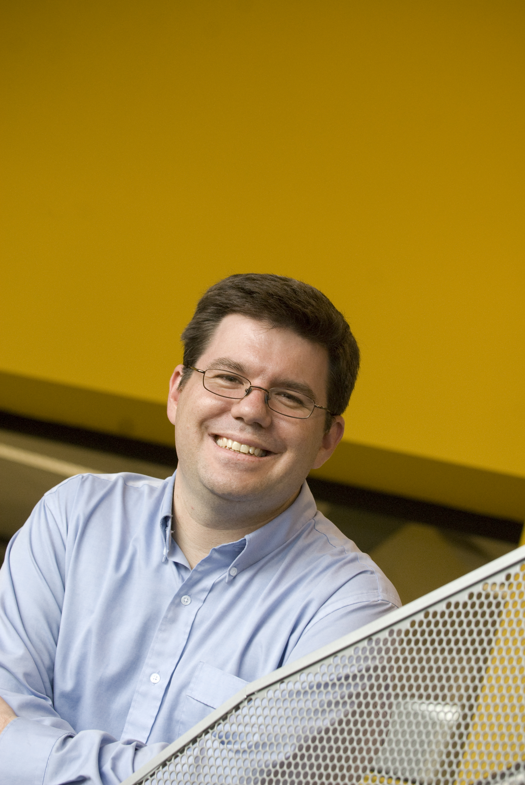

**Bernard Rolfe** completed a combined Economics and Engineering degree with honours in 1995 from the Australian National University (ANU), and returned in 1997 to the ANU to pursue a PhD in novel methods of inverse modeling metal forming processes (completed in 2002). In 2005 Bernard joined Deakin as a Lecturer in Mechanical Engineering. Currently Bernard is an Associate Professor (Mechanical) at Deakin University in Australia. **His current research focus is the forming of lightweight structures, including the development of better material models for metal forming**.

A/Prof Bernard Rolfe has been researching metal forming for the past 20 years. His focus has been on the forming of lightweight structures. Primarily he and his team have investigated stamping, but they have also studied other processes such as roll forming and more recently 3D printing.

Steel is an amazing material. Humans have been working, forming, and investigating steel for over 2000 years. And yet we continue to discover more ways to create interesting steel grades. Steel offers so many paths to desired performance. Traditionally, increasing the strength of steels has been achieved by quenching (forming martensite) and micro alloying (to enable strength and formability). Only in the past few decades has work been done on using precipitates to harden steels, which is still another way for steel to meet performance targets. Deakin’s steel group is one of the research leaders investigating precipitate steels.

This talk will review Bernard’s recent short experience working at Carnegie Mellon University (Pittsburgh – USA) to investigate ways to simulate the formation of clusters in precipitate steels. A kind note to the audience, Bernard is at the beginning of this journey to model these steels.